**Orange Juice Music App – User Manual**

Home Screen:

Upon opening the application, you will be greeted by the application home screen. The home screen has four buttons labelled as follows:

* “Generate Music” – This button will open a new window where you can generate random music based upon customizable weights.
* “Play Midi” – This button will open a new window where you can select a preexisting midi file on your computer and play it.
* “Play Piano” – This button will open a new window where you can play a virtual piano using your mouse or computer keyboard.
* “Exit” – This button will close the window with the application home screen.

Figure 1: (Application Home Screen)

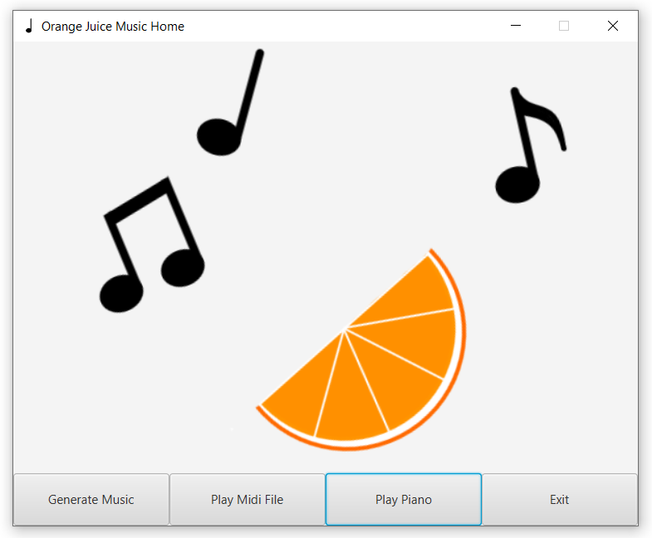

Orange Juice Midi Generator:

Having clicked the “Generate Music” button on the home screen, you will have been brought to the Orange Juice Midi Generator. Upon first opening the Orange Juice Midi Generator, there will only be two buttons visible at the bottom of the window (see Figure 2.A). Clicking the “Generate Midi” button will make more buttons visible if a song is successfully generated with the current settings (see Figure 2.B). The buttons which have newly appeared will allows you to play and save the midi file that you have just generated. In general, the customizable fields are displayed with a focus on note pitch towards the right half of the window and a focus on rhythm towards the left half of the window. A brief explanation of the impact of each of the customizable fields is as follows:

* “Scale Type” – Determines which pool of chords to use (chords only come from notes in the scale and are not customizable) and which set of “Next Note Weights” to use (these note weights have default values but are customizable).
* “Root Note” – Determines the root note of the scale (is C by default).
* “Generate Melody/Bass Part” – Determines whether or not there will be a melody/bass part in the generated song.
* “Melody/Bass Range” – Allows the user to specify the range of notes that the melody/bass part is likely to occupy (if the range is less than an octave, some notes might appear outside of the range depending on the “Next Note Weights”).
* “Harmonic/Melodic Bias” – If the “Scale Type” is either Harmonic Minor or Melodic Minor, this setting determines the likelihood that the “Next Note Weights” come from the “Original” Scale Type (Harmonic/Melodic Minor) or from the Natural Minor “Next Note Weights”.
* “Note Bias” – This setting determines the likelihood that the next note will depend upon weights from the chord of the current measure or from the scale’s “Next Note Weights”.
* “Starting Note” – Determines the weights for the next note if the previous note was at the current position in the scale. For example, if the “Root Note” is D, then “Starting Note: III” refers to the previous note being F#. If the “Root Note” is D, then “Starting Note: iii” refers to the previous note being F natural.
* “Next Note Weights Ascend/Descend” – The weighted likelihood that the next note will have the given position relative to the “Starting Note”. For the “Ascend” weights, “I*” refers to the “Starting Note” and “VIII” is one octave above the “Starting Note”. For the “Descend Weights”, “VIII*” refers to the “Starting Note” and “I” is one octave below the “Starting Note”.
* “Time Signature” – Determines the time signature of the randomly generated song (currently supported time signatures are: 2/4, 3/4, 4/4, 5/4).
* “Note Length Weights” – Determines the likelihood that a note will have the given length. (A value of zero does not mean that a note will never have that specified note length. It depends how much room is left in the given measure. For example, if the “Time Signature” is 2/4, and all the “Note Length weights” except for “Dotted Eighth” are zero, then the measure will first be filled with two dotted eighth notes, but then as there is only room for a regular eighth note left, the last note will not be a dotted eighth note.)
* “Rest Weight” – Determines the likelihood that any given note (regardless of note length) will be a rest.
* “Tempo in BPM” – Determines the tempo in beats per minute for the randomly generated song.
* “Measures” – Determines the number of measures that will be randomly generated in the song (maximum is 1024).
* “Random Seed” – Determines the seed used for the random number generator which generates the song. (The seed will be based upon the current system time if left blank or if an invalid seed is entered.)
* “Generate Midi” – Generates a randomly generated midi file based upon the settings when the “Generate Midi” button was clicked. After changing settings, the button must be pressed again to generate a new song.
* “Save Midi” – Allows the user to save the randomly generated song as a midi file.
* “Play” – Plays the most recently generated song. (This button is not visible while a song is playing.)
* “Pause” – This button is only visible while a song is playing. It pauses the playback of the current song.
* “Stop” – This button will stop the song if it is currently playing and reset the position in the song back to the beginning.
* “Exit” - This button will close the Orange Juice Music Generator and reopen the Orange Juice Music Home Screen if it was closed.

Figure 2.A: (Orange Juice Midi Generator Before Generation)

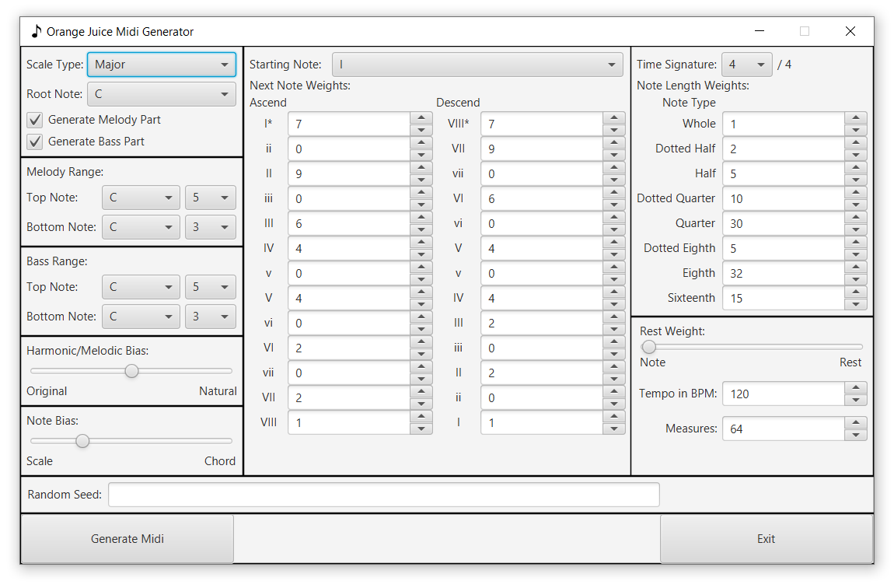

Figure 2.B: (Orange Juice Midi Generator After Generation)

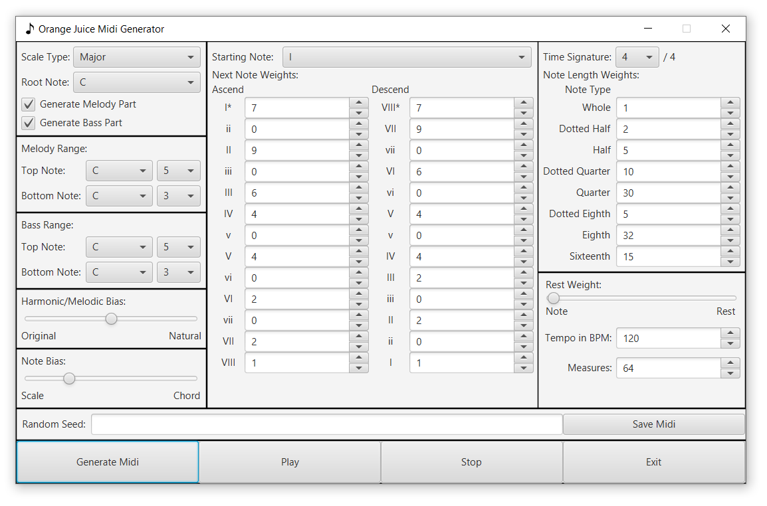

**CAUTION!**

If you close the Orange Juice Midi Generator or press the “Generate Midi” button without saving your previously generated song, it will be lost forever (unless you can remember and reproduce the exact settings and random seed used to generate that song, which is unlikely).

Orange Juice Midi Player:

Having clicked the “Play Midi File” button on the home screen, you will have been brought to the Orange Juice Midi Player. Upon first opening the Orange Juice Midi Player, there will only be two buttons visible at the bottom of the window (see Figure 3.A). Clicking the “Load Midi” button will make more buttons visible if a midi file is successfully loaded (see Figure 3.B). The buttons which have newly appeared will allows you to play the midi file that you have just loaded. A brief explanation of the Orange Juice Midi Player is as follows:

* “Current File:” – Displays the name of the currently loaded file.
* “00:00:00” – This value displays the time (hours : minutes : seconds) in the currently playing midi file and will count up as the midi file plays, pause when the midi file is paused, and get reset to zero when the midi file is stopped. If the midi file is longer than a day, the timer will return to “00:00:00” at the 24-hour mark.
* “Load Midi” – This button will allow the user to choose a midi file to load into the Orange Juice Midi Player and play.
* “Play” – Plays the currently loaded midi file. (This button is not visible while a midi file is playing.)
* “Pause” – This button is only visible while a midi file is playing. It pauses the playback of the current midi file.
* “Stop” – This button will stop the midi file if it is currently playing and reset the position of the playback of the midi file back to the beginning.
* ““Exit” - This button will close the Orange Juice Midi Player and reopen the Orange Juice Music Home Screen if it was closed.

Figure 3.A: (Orange Juice Midi Player Before Loading Midi File)

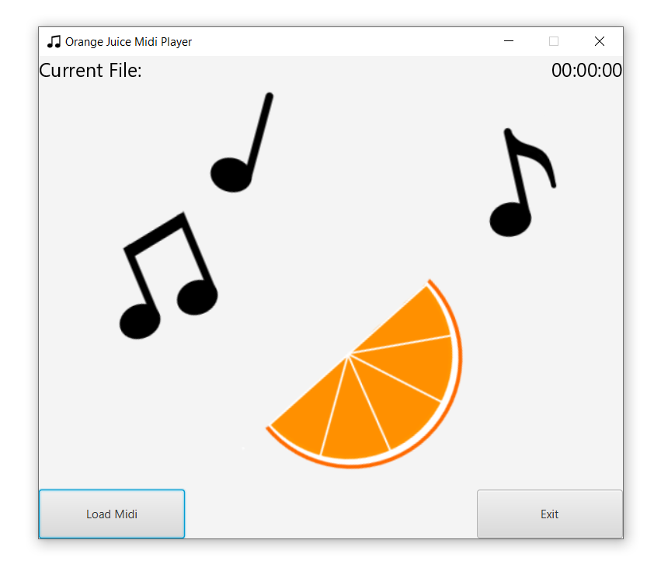

Figure 3.B: (Orange Juice Midi Player After Loading Midi File)

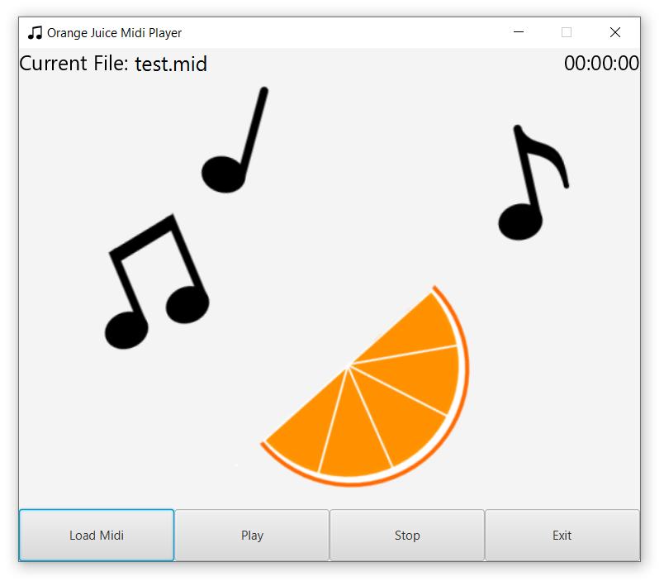

Orange Juice Piano:

Having clicked the “Play Piano” button on the home screen, you will have been brought to the Orange Juice Piano. Upon first opening the Orange Juice Piano, there will be 18 keys displayed (10 white keys, 8 black keys) with the lowest white key displayed being A3. Like a regular piano, the Orange Juice Piano supports notes from A0 to C8 (a total of 88 keys). The Orange Juice Piano can be played with the mouse by left-clicking and dragging the mouse over the keys, or by using your computer’s keyboard (to see the keyboard key bindings for the piano keys, check the “Display Key Mapping” checkbox, only ten white keys will have bindings, the number of black keys with key bindings depends on the position of the white keys). A brief explanation of the Orange Juice Piano’s option panel (on the right side of the window) is as follows:

* “^^^” (Red) – Moves the key mapping up by one octave. The key display will move to ensure that all mapped keys are visible. The key mapping will not exceed the bounds of the piano. (This can also be accomplished by pressing the V key.)
* “^” (Red) – Moves the key mapping up by one white key. The key display will move to ensure that all mapped keys are visible. The key mapping will not exceed the bounds of the piano. (This can also be accomplished by pressing the C key.)
* “v” (Red) – Moves the key mapping down by one white key. The key display will move to ensure that all mapped keys are visible. The key mapping will not exceed the bounds of the piano. (This can also be accomplished by pressing the X key.)
* “vvv” (Red) – Moves the key mapping down by one octave. The key display will move to ensure that all mapped keys are visible. The key mapping will not exceed the bounds of the piano. (This can also be accomplished by pressing the Z key.)
* “^^^” (Blue) – Moves the key display up by one octave. The key mapping will move to ensure that all mapped keys are visible based upon the new display. The key display will not exceed the bounds of the piano.
* “^” (Blue) – Moves the key display up by one white key. The key mapping will move to ensure that all mapped keys are visible based upon the new display. The key display will not exceed the bounds of the piano.
* “v” (Blue) – Moves the key display down by one white key. The key mapping will move to ensure that all mapped keys are visible based upon the new display. The key display will not exceed the bounds of the piano.
* “vvv” (Blue) – Moves the key display down by one octave. The key mapping will move to ensure that all mapped keys are visible based upon the new display. The key display will not exceed the bounds of the piano.
* “Add Note” – Adds a note to the notes currently displayed on the screen. The note added will be higher than those currently displayed, unless the display has reached the upper limit of the piano, in which case the note is added below those currently displayed. (Notes can no longer be added if the piano is currently displaying all 88 keys, 52 white keys and 36 black keys.)
* “Remove Note” – Removes a note from the notes currently displayed on the screen. The note removed will be the top note currently displayed. If the top note currently displayed is a mapped key, then the note mapping is shifted down by one white key to ensure that all mapped keys are displayed. (Notes can no longer be removed if the piano is currently displaying only the mapped keys, of which there are ten white keys.)
* “Display Key Mapping” – If checked, the keyboard key bindings for the piano keys will be displayed in red text on the piano keyboard.
* “Display Note Names” – If checked, the note names for the displayed white piano keys will be displayed in blue text in a form like “A3”.
* “Volume” – This slider determines the volume of the notes played on the piano. (Unlike a real piano, pressing the keyboard keys or the mouse button harder will not make the sound louder, only this volume slider will make the sound louder.)
* “Piano” – This drop-down menu allows you to select from 10 different midi instruments to play. The instrument is “Piano” by default.
* “Exit” - This button will close the Orange Juice Piano and reopen the Orange Juice Music Home Screen if it was closed.

Figure 4.A: (Orange Juice Piano Upon Opening)

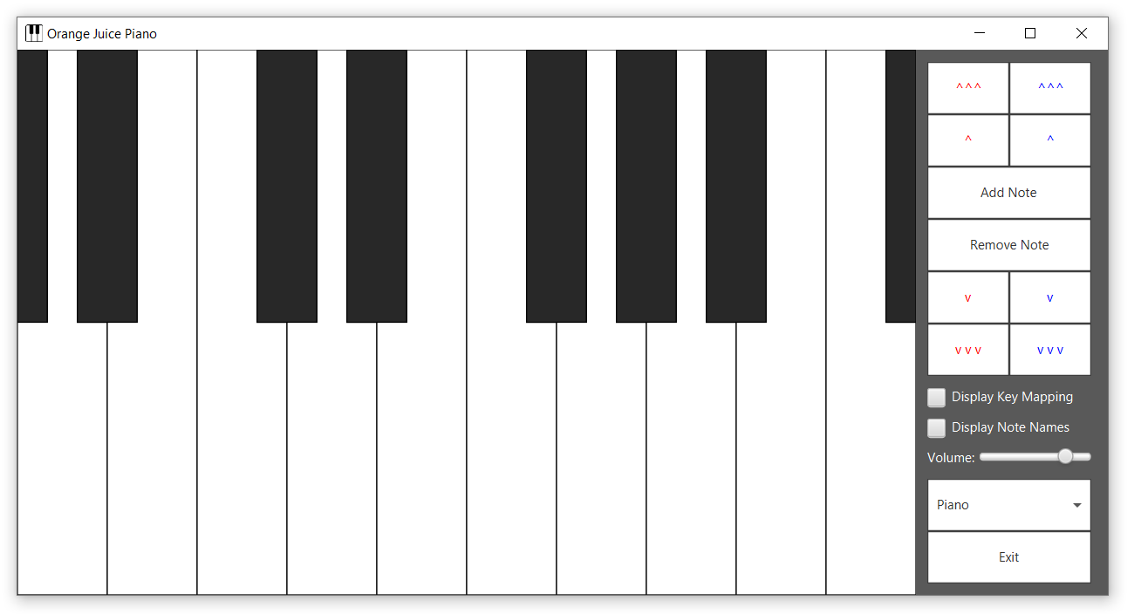

Figure 4.B: (Orange Juice Piano After Displaying Key Mapping)

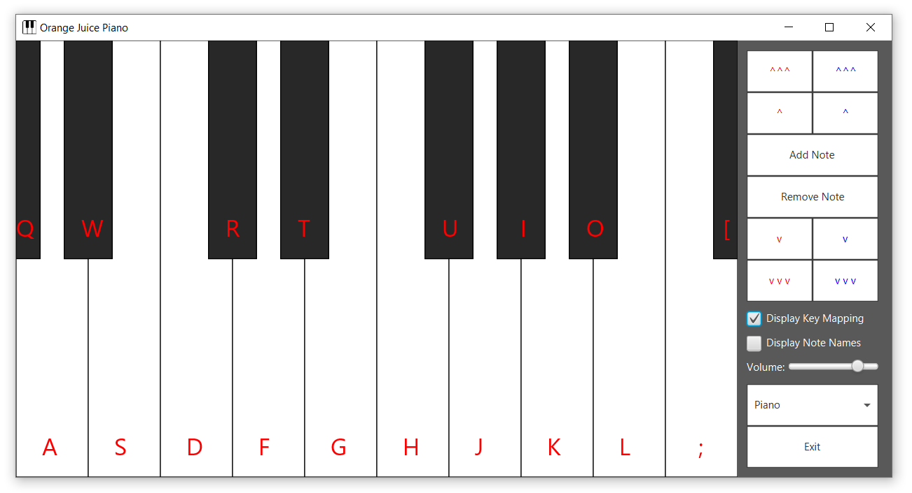

Figure 4.C: (Orange Juice Piano After Displaying Note Names)

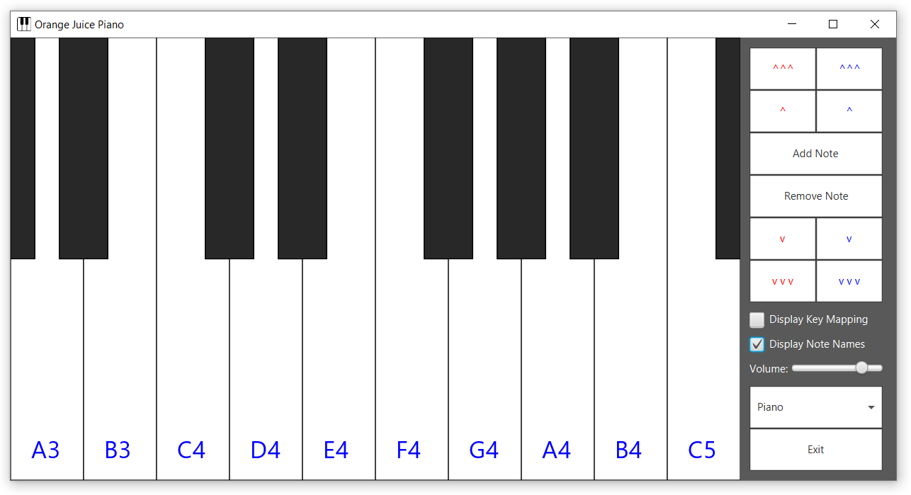

Figure 4.D: (Orange Juice Piano After Displaying Key Mapping and Note Names)

